**Microeconomics ECO2001**

**Assignment (20%)**

**Fall 2019**

**Note: Individual Assignment to be submitted on or before 20th October 2019 via TurnitIn.**

1. SCENARIO 1: Consider the following data for the harvest of crabs versus the harvest of fish off the coast of Virginia in answering the following questions. **(2 Marks)**

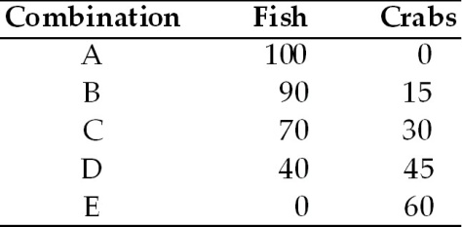

1. Refer to Scenario 1. Graph the production possibilities frontier and calculate the

average opportunity cost of any of the first fifteen crabs produced.

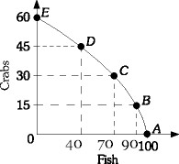

**15 C= 10 F**

**Average**  opportunity cost of any of the first fifteen crabs produced = 10/15= 2/3 fish

1. Refer to Scenario 1. What is the economic significance of 25 fish captured and 25 crabs captured?

**The economic significance of capturing 25 fish and 50 crabs is that the harvest would be inside the PPC and hence inefficient in nature. This situation is below the PPC and some of the resources are unutilized.**

1. Refer to Scenario 1. Explain how this economy might be able to produce 45 fish and 45 crabs?

With current resources unattainable for can be done through growth of some of the resources involved.

1. Refer to Scenario 1. If this economy is currently producing 30 crabs and 40 fish how is it possible for it to produce more of both?

This is possible because there are more resources available and the economy can produce anything between points C and D which would increase both.

1. Refer to Scenario 1. Assume this economy could either be at Point B or Point C. From which of these points is it more costly to produce more crabs? Explain your answer.

Point C is the point where it is more costlier for the economy to produce more crabs.

1. The table below shows the supply and demand for pencils: **(2 Marks)**

|  |  |  |
| --- | --- | --- |
| **Price** | **Quantity Demanded** | **Quantity Supplied** |
| $ 0.60 | 10,000 | 15,000 |
| 0.50 | 12,000 | 12,000 |
| 0.40 | 14,000 | 9,000 |
| 0.30 | 16,000 | 6,000 |
| 0.20 | 18,000 | 3,000 |

1. What is the equilibrium price and quantity? How can you tell?

Equilibrium price is $.50 and Equilibrium price is 12,000 units.

Equilibrium is where the QD equals QS.

1. Suppose the current price is $0.20. What situation is present? Will the price remain at $0.20? Why or why not?

At a price of $.20 , QD would be 18,000 and QS is 3,000 which means there are excess quantity demanded. The situation would mean price would move upward till QS and QD becomes equal again.

1. The figure below shows the market for cotton fabric: **(2 Marks)**

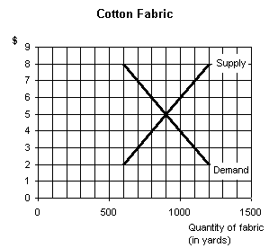

1. If the price in the market is $8.00, would the market be at equilibrium? If not, is there a shortage or a surplus? How large is the shortage or surplus?

The QD = 500 and QS = 1100

There is a surplus in market and not equilibrium.

Price would move downwards as supply is greater than demand.

(b.)I f the price in the market is $5.00, would the market be at equilibrium? If not, is there a shortage or a surplus? How large is the shortage or surplus?

The QD = 900 and QS = 900

There is equilibrium as there is neither any shortage nor surplus.

(c.) If the price in the market is $2.00, would the market be at equilibrium? If not, is there a shortage or a surplus? How large is the shortage or surplus?

The QD = 1200 and QS = 600

There is a shortage as QD> QS and hence there is no equilibrium.

Price would move upwards as supply is lower than demand.

1. The lumber market is currently in equilibrium at a price of $2 per foot. A new technology is developed that reduces waste and increases efficiency in the production of lumber. Show graphically the effect of this new technology in the lumber market. What will happen to the equilibrium price and quantity sold? **(1 Mark)**

Supply

Price

S2

E

$2.00

1.00

Demand

Quantity of lumber (ft.)

Q1 Q2

The Supply curve moves to the right as more quantity are produced. as a result of which the equilibrium quantity increases to Q2 and price declines from $2 to $1.

5.Draw a graph showing the impact of students returning to campus in August on the market for pizza in a college town. **(1 Mark)**

Price

Supply

D2

D1

Quantity of pizza

Demand curve shift towards the right and supply curve remains the same.

This increases the equilibrium quantity and Equilibrium price new price is much higher.

Thus the impact of students returning to campus in August on the market for pizza in a college town. Is that both equilibrium Quantity and equilibrium price increases.

6.When the price of a Sony portable CD player rises from $125 to $150, quantity demanded falls from 750 per week to 600. Calculate price elasticity of demand using midpoint method and what would happen to total revenue? Draw a graph to show the changes in price and quantity. What can we say about the price elasticity of demand for Sony portable CD players? Draw a graph to show price elasticity of demand? **(2 Marks)**

**Answer**

price elasticity of demand using midpoint method =% change in QD/ % change in price = 22.22% / 18.18% = 1.222

% change in QD = (750—600)/ (750+600)/2 = 150/ 675 = 22.22%

% change in Price = (150-125)/ (125+150)/2 = 25/ 137.5 = 18.18%

As the price increases total revenue declines for the firm. (ed>1)

Price

Supply

D1

D2

Quantity of portable player

7.When the price of bread rises from $1.25 to $1.50 per loaf, quantity demanded falls from 5,800 per week to 5,500. Calculate price elasticity of demand using midpoint method and what would happen to total revenue? Draw a graph to show the changes in price and quantity. What can we say about the price elasticity of demand for bread? Draw a graph to show price elasticity of demand? **(2 Marks)**

**Answer**

price elasticity of demand using midpoint method =% change in QD / % change in price

= 5.31% / 18.18% = .292

% change in QD = (5800—5500)/ (5800+5500)/2 = 300/ 5650 = 5.31%

% change in Price = (1.50-1.25)/ (1.25+1.50)/2 = .25/ 1.375 = 18.18%

As the price increases total revenue increases for the firm. (ed<1)

As the price increases total revenue declines for the firm. (ed>1)

Price

Supply

D1

D2

Quantity of Bread

***8.Refer to the data provided in Table 8.4 below to answer the following questions.* (1 Mark)**

**Table 8.4**

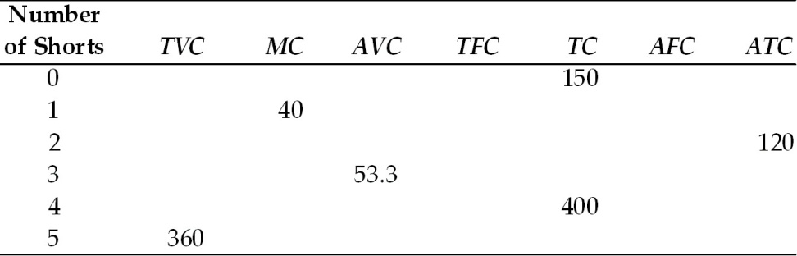

1. Refer to Table 8.4. If Scott produces five pairs of shorts, what are his total costs?

Total cost ( 5 pairs) = 150 + 360 = 510

1. Refer to Table 8.4. If Scott produces four pairs of shorts, what are his average fixed costs?

Average fixed cost = 150/4 = 37.5

1. Refer to Table 8.4. If Scott produces two pairs of shorts, what are his average variable costs?

Average fixed cost = 150/2 = 75

1. Refer to Table 8.4. If Scott produces four pairs of shorts, what are his average variable costs?

Average variable cost = 250/4 = 62.5

1. Refer to Table 8.4. Assume that Scott Board Shorts is producing in a perfectly competitive output market. The price of a pair of shorts is $40. To maximize profits, how many shorts should Scott produce?

As MR= MC at 1 unit , the firm shall produce 1 unit to maximize profitability.

1. You run a firm that produces T-shirts that are sold in a perfectly competitive market. Your firm faces the following cost and revenue schedule: **(1 Mark)**

|  |  |  |  |  |  |  |  |  |  |  |
| --- | --- | --- | --- | --- | --- | --- | --- | --- | --- | --- |
| **Quantity** | **Price** | **TR** | **TC** | **Profit** | **MR** | **MC** | **FC** | **VC** | **ATC** | **AVC** |
| 0 | 12 | 0 | 5 | 0 | ---- | ---- | 5 | 0 | ---- | ---- |
| 1 | 12 | 12 | 12 | 0 | 12 | 7 | 5 | 7 | 5 | 7 |
| 2 | 12 | 24 | 22 | 2 | 12 | 10 | 5 | 17 | 2.5 | 8.5 |
| 3 | 12 | 36 | 33 | 3 | 12 | 11 | 5 | 28 | 1.66 | 9.33 |
| 4 | 12 | 48 | 45 | 3 | 12 | 12 | 5 | 40 | 1.25 | 10 |
| 5 | 12 | 60 | 60 | 0 | 12 | 15 | 5 | 55 | 1 | 11 |
| 6 | 12 | 72 | 78 | -6 | 12 | 18 | 5 | 73 | .866 | 12.166 |

Fill in the table above. What is your firm's profit maximizing level of output?

The profit maximizing level of output is 4 units ( MR=MC)

1. Market price of $200,000 per home. Fill in the table. **(2 Marks)**

|  |  |  |  |  |  |
| --- | --- | --- | --- | --- | --- |
| **Quantity** | **Price ($)** | **Total Revenue ($)** | **Marginal Revenue ($)** | **Total Cost ($)** | **Marginal Cost ($)** |
| 0 | 200,000 | **0** | **0** | 180,000 | 0 |
| 1 | 200,000 | **200,000** | **200,000** | 340,000 | 160,000 |
| 2 | 200,000 | **400,000** | **200,000** | 480,000 | 140,000 |
| 3 | 200,000 | **600,000** | **200,000** | 600,000 | 120,000 |
| 4 | 200,000 | **800,000** | **200,000** | 740,000 | 140,000 |
| 5 | 200,000 | **1,000,000** | **200,000** | 900,000 | 160,000 |
| 6 | 200,000 | **1,200,000** | **200,000** | 1,080,000 | 180,000 |
| 7 | 200,000 | **1,400,000** | **200,000** | 1,280,000 | 200,000 |
| 8 | 200,000 | **1,600,000** | **200,000** | 1,500,000 | 220,000 |
| 9 | 200,000 | **1,800,000** | **200,000** | 1,740,000 | 240,000 |
| 10 | 200,000 | **2,000,000** | **200,000** | 2,000,000 | 260,000 |
| 11 | 200,000 | **2,200,000** | **200,000** | 2,280,000 | 280,000 |
| 12 | 200,000 | **2,400,000** | **200,000** | 2,580,000 | 300,000 |

1. Ultimately **how many units** will be produced?

Ultimately **7 many units** will be produced.

1. What is the **Economic Profit**?

Economic profit is $120,000 ( 1,400,000-1,280,000)

1. Market price falls to $160,000. Fill in the table. **(2 Marks)**

|  |  |  |  |  |  |
| --- | --- | --- | --- | --- | --- |
| **Quantity** | **Price**  **($)** | **Total Revenue ($)** | **Marginal Revenue ($)** | **Total Cost ($)** | **Marginal Cost ($)** |
| 0 | 160,000 |  | **0** | 180,000 |  |
| 1 | 160,000 | **160,000** | 160,000 | 340,000 | 160,000 |
| 2 | 160,000 | **320,000** | 160,000 | 480,000 | 140,000 |
| 3 | 160,000 | **480,000** | 160,000 | 600,000 | 120,000 |
| 4 | 160,000 | **640,000** | 160,000 | 740,000 | 140,000 |
| 5 | 160,000 | **800,000** | 160,000 | 900,000 | 160,000 |
| 6 | 160,000 | **960,000** | 160,000 | 1,080,000 | 180,000 |
| 7 | 160,000 | **1,120,000** | 160,000 | 1,280,000 | 200,000 |
| 8 | 160,000 | **1,280,000** | 160,000 | 1,500,000 | 220,000 |
| 9 | 160,000 | **1,440,000** | 160,000 | 1,740,000 | 240,000 |
| 10 | 160,000 | **1,600,000** | 160,000 | 2,000,000 | 260,000 |
| 11 | 160,000 | **1,760,000** | 160,000 | 2,280,000 | 280,000 |
| 12 | 160,000 | **1,920,000** | 160,000 | 2,580,000 | 300,000 |

1. How many units will be produced?

Ultimately **5 many units** will be produced.(MR=MC)

1. The **economic profits** are now equal to

Economic profit is - $100,000 ( 800,000-900,000)

1. market price falls to $120,000. **(2 Marks)**

|  |  |  |  |  |  |
| --- | --- | --- | --- | --- | --- |
| **Quantity** | **Price ($)** | **Total Revenue ($)** | **Marginal Revenue ($)** | **Total Cost ($)** | **Marginal Cost ($)** |
| 0 | 120,000 | **0** |  | 180,000 |  |
| 1 | 120,000 | **120,000** | **120,000** | 340,000 | 160,000 |
| 2 | 120,000 | **240,000** | **120,000** | 480,000 | 140,000 |
| 3 | 120,000 | **360,000** | **120,000** | 600,000 | 120,000 |
| 4 | 120,000 | **480,000** | **120,000** | 740,000 | 140,000 |
| 5 | 120,000 | **600,000** | **120,000** | 900,000 | 160,000 |
| 6 | 120,000 | **720,000** | **120,000** | 1,080,000 | 180,000 |
| 7 | 120,000 | **840,000** | **120,000** | 1,280,000 | 200,000 |
| 8 | 120,000 | **960,000** | **120,000** | 1,500,000 | 220,000 |
| 9 | 120,000 | **1,080,000** | **120,000** | 1,740,000 | 240,000 |
| 10 | 120,000 | **1,200,000** | **120,000** | 2,000,000 | 260,000 |
| 11 | 120,000 | **1,320,000** | **120,000** | 2,280,000 | 280,000 |
| 12 | 120,000 | **1,440,000** | **120,000** | 2,580,000 | 300,000 |

1. How many units will be produced?

Ultimately **3 many units** will be produced.(MR=MC)

1. The **economic profits** are now equal to

Economic profit is - $240,000 ( 360,000-600,000)