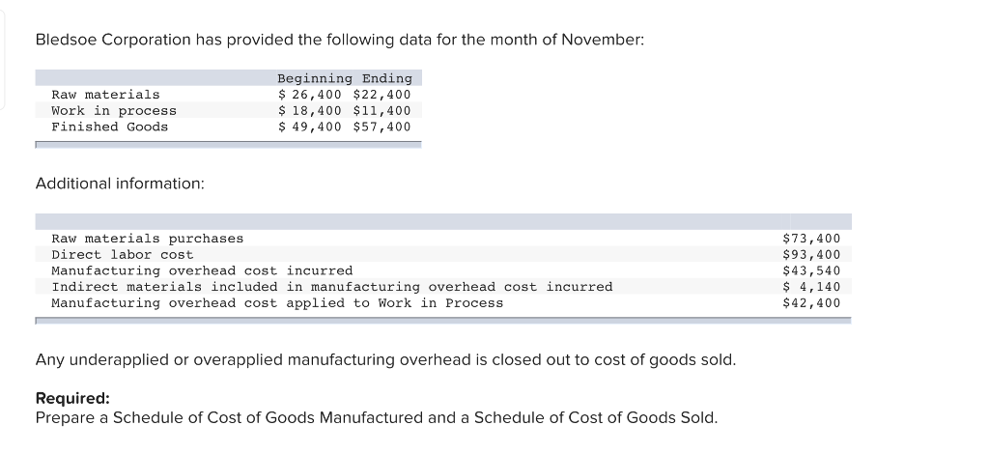

Answer

|  |  |
| --- | --- |
|  | $ |
| Beginning Inventory of Direct Material | 26,400 |
| Add: Purchases | 73,400 |
| Inventory available for use | 99,800 |
| Less: Ending Inventory of Direct Material | 22,400 |
| Raw Material Used in Production | 77,400 |
| Less: Indirect Material Used | 4,140 |
| Beginning Inventory of Direct Material | 26,400 |
| Direct Materials | 73,260 |
| Direct Labour | 93,400 |
| Applied Factory Overhead | 42,400 |
| Total Manufacturing Costs | 209,060 |
| Add: Beginning inventory for Work In Process | 18,400 |
| Total Cost of Work In Process Inventory | 227,460 |
| Less: Ending Inventory of Work In Process | 11,400 |
| Total Cost of Goods Manufactured | 216,060 |
|  |  |
| Beginning Finished Goods Inventory | 49,400 |
| Add: Cost of Goods Manufactured | 216,060 |
| Cost of Goods Available for sale | 265,460 |
| Less: Closing Inventory of Finished Goods | 57,400 |
| Unadjusted Cost of Goods Sold | 208,060 |
| Add: Under Applied Overheads | 1,140 |
| Adjusted Cost of Goods Sold | 209,200 |

|  |  |  |
| --- | --- | --- |
| Direct Labor |  |  |
|  |  |  |  |
|  | Applied Factory Overhead | 42400 |  |
|  | Total Manufacturing Costs | 209060 |  |
|  | Add: Beginning inventory for Work In Process | 18400 |  |
|  | Total Cost of Work In Process Inventory | 227460 |  |
|  | Less: Ending Inventory of Work In Process | 11400 |  |
|  | Total Cost of Goods Manufactured | 216060 |  |
| Cost of Goods Sold |  |  |
|  |  |  |  |
|  | Beginning Finished Goods Inventory | 49400 |  |
|  | Add: Cost of Goods Manufactured | 216060 |  |
|  | Cost of Goods Available for sale | 265460 |  |
|  | Less: Closing Inventory of Finished Goods | 57400 |  |
|  | Unadjusted Cost of Goods Sold | 208060 |  |
|  | Add: Under Applied Overheads | 1140 |  |
|  | Adjusted Cost of Goods Sold | 209200 |  |