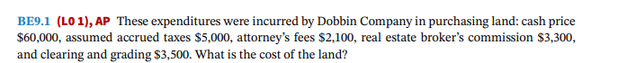

**Step 1**

The cost of land includes the purchase price and many other expenses such as real estate commissions paid, title search and title transfer fees, title insurance premiums, and the cost of surveying, clearing & grading, etc.

Explanation

While computing the cost of land the purchase price will be added with all the costs that are incurred to make land usable for the buyer and the salvage value if any from any existing structures etc. must be subtracted.

**Step 2**

The following Expenses were provided for computing the cost of land.

Cash paid = $ 60,000

Accrued taxes – $ 5,000

Real estate brokers commission -$ 3,300

Clearing and grading charges - $ 3,500

Attorney fee - $ 2,100

Cost of the land = 60000+5000+2100+3300+3500= $73900

Explanation

The land cost for Dobbin will include the cash price paid for the land and the Accrued taxes on the land cash price. The attorney fee is an admissible expense for the calculation of the cost of land and also the Brokerage fees. Clearing and grading charges will also be included in the cost of land as the same is incurred to make the land usable for the company.

**Final Answer**

The cost of land as per the provided expenditures for Dobbin Company is estimated to be $73,900. This Cost will be entered as the Land cost in the financial statements.