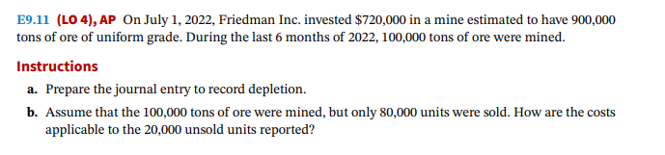

**Computation of depletion cost per unit:**

**Depletion cost per unit = ( cost of investment – salvage)/ Expected tons to be extracted**

**Depletion cost per tonne = (720,000-0) 900,000 = $ .8 per tonne**

**Therefore, The Depletion Cost per unit is $0.80**

**a)**

Inventory or Depletion expense = 100,000*0.80 = 80,000

Depletion Expenses  $80,000

     Accumulated Depletion Expenses  $80,000

(to record depletion Expenses)

**b)**

**Cost applicable to Units unsold**

Units = 20,000

Cost of units unsold = 20000*.8 = $16,000

**Cost of Units unsold = $16,000**